# Chapter 5 - Lessons for Success

**All Lectures Uploaded on YouTube:** [**https://tinyurl.com/fkm9-english**](https://tinyurl.com/fkm9-english)

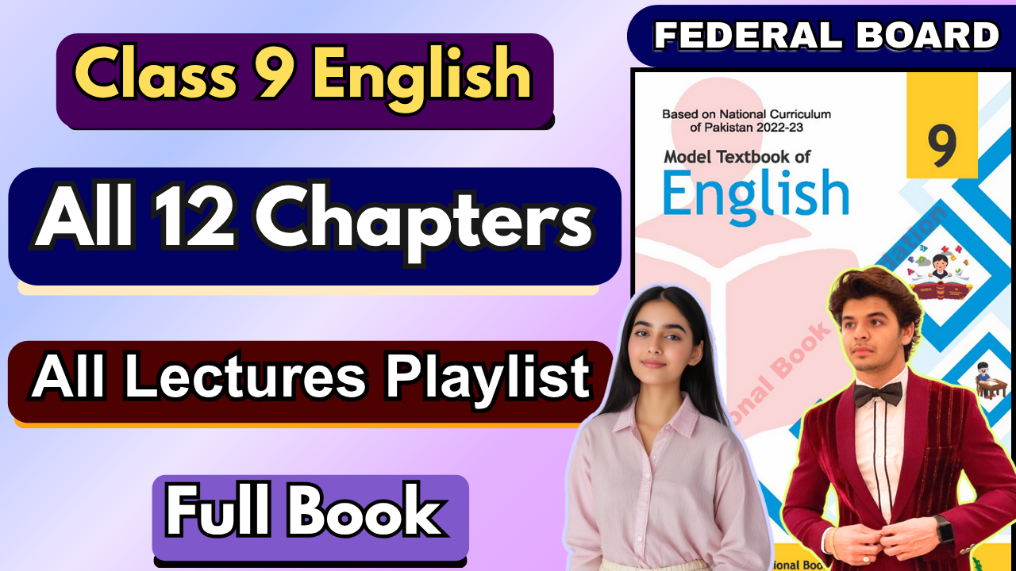

# Question/Answers

#### What is the main theme of the article about Jeff Bezos?

**Ans.** The article’s main theme is to highlight Jeff Bezos' journey, and his philosophies on risk-taking, decision-making, finding one's passion, embracing innovation, and maintaining individuality, contributing to his success as a leader and entrepreneur.

#### Which of Bezos' lessons do you find most compelling, and why?

**Ans.** The lesson about "taking risks" is particularly compelling. Bezos emphasizes the importance of pursuing one's dreams and not fearing failure. His decision to leave a stable job at a hedge fund to launch Amazon demonstrates the value of following one’s passion and taking calculated risks. This resonates because it encourages courage and self-belief in pursuing ambitious goals.



#### Can you think of a personal or professional situation where one of Bezos' lessons might apply?

**Ans.** In a professional setting, Bezos's lesson on making quick decisions could apply. For example, in project management, delaying decisions can slow down progress. Multiple people depend on your decision, so you need to be quick.

Following his advice, one could focus on making reversible decisions faster to maintain momentum and encourage experimentation.

#### How might Bezos' advice on decision-making and risk-taking benefit someone in their career?

**Ans.** Bezos' advice can help individuals embrace innovation and overcome the fear of failure, encouraging them to seize opportunities. By understanding that many decisions are reversible, professionals can experiment and adapt without fear of permanent consequences, leading to creativity and growth.

#### Do you agree with Bezos' perspective on embracing distinctiveness? Why or why not?

**Ans.** Yes, I agree with Bezos' perspective. Embracing distinctiveness fosters innovation and personal authenticity. While challenging, staying true to oneself can lead to unique contributions and long-term success in both personal and

professional life. It can lead to self-satisfaction and you will not have the regret of not trying.

**Q: Deduce and fill meanings of words/phrases:**

* + **tangential**:
    - **Deduced Meaning**: Slightly related or peripheral.
    - **Dictionary Meaning**: Relating to or along a tangent; diverging from a previous course or line; only superficially relevant.

#### high-velocity decisions:

* + - **Deduced Meaning**: Quick and efficient decisions.
    - **Dictionary Meaning**: Decisions made at high speed, often under pressure.

#### intuition:

* + - **Deduced Meaning**: Instinctive knowledge or understanding without reasoning.
    - **Dictionary Meaning**: The ability to understand something immediately, without the need for conscious reasoning.

#### distinctiveness:

* + - **Deduced Meaning**: Uniqueness or individuality.
    - **Dictionary Meaning**: The quality of being easily recognizable as different or unique.

#### suboptimal:

* + - **Deduced Meaning**: Not the best or below an ideal standard.
    - **Dictionary Meaning**: Less than the highest standard or quality.

#### transitioned:

* + - **Deduced Meaning**: Moved or changed from one state to another.
    - **Dictionary Meaning**: The process or period of changing from one state or condition to another.

**Compound Prepositions**

* + Prepositions are made by combining two or more prepositional words.
  + **Examples:** *About, across, according to, aside from, because of, in case of, due to, instead of, in addition to,* etc.

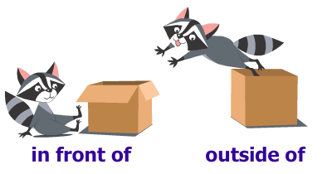

**Prepositional Phrases**



* + Groups of words start with a preposition and act as modifiers (cannot stand alone as a sentence).

#### Types of Prepositional Phrases:

1. **Adjectival Phrases:** Modify nouns or pronouns to describe "which" or "what kind."

* Example: *The boy with the blue hat.*

*2.* **Adverbial Phrases:** Modify verbs, adjectives, or adverbs to describe "how," "where," "when," or "to what extent."

* + Example: *She ran with pride.*

#### Exercise 1

1. The cat jumped **onto** the table.
2. I’m going **to** the park **with** my friends.
3. The keys are hidden **under** the flowerpot.
4. The cookies are **on** the plate.
5. The restaurant is **beside** the street.
6. The pen is **on** the notebook.
7. She walked **through** the high street to reach the playground.
8. The bookshelf is **against** the wall.
9. The ball rolled **down** the stairs.
10. They sat **by** the fire to keep warm.
11. I can see the moon **above** the clouds.
12. The dog ran **across** the street to chase the squirrel.
13. She placed the vase **on** the shelf.
14. The car swerved **through** the crowd of people.
15. The bird built its nest **among** the tree branches.



### Exercise 2

#### The dog barked. The postman arrived.

The dog barked at the arrival of the postman.

#### Jenny laughed. Her brother told a joke.

Jenny laughed at her brother’s joke.

#### We bought ice cream. We went to the beach.

We bought ice cream on our way to the beach.

#### She went to the store. She bought some groceries.

She went to the store for some groceries.

#### He studied all night. He passed the exam.

He passed the exam after studying all night.

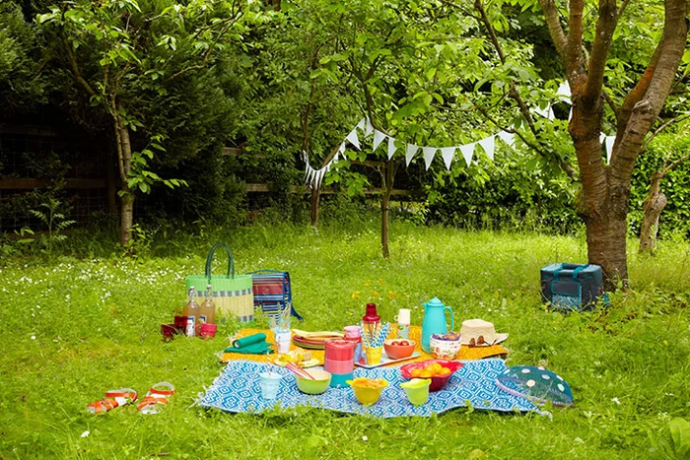

#### They went to the beach. They played volleyball.

They played volleyball at the beach.

#### I woke up late. I missed the bus.

I missed the bus because of waking up late.

#### They went to the park. They had a picnic.

They had a picnic at the park.

## Exercise 3

1. **The birds flew over the mountains. Prepositional phrase:** over the mountains
2. **The dog ran after the ball. Prepositional phrase:** after the ball
3. **The flowers bloomed between the trees. Prepositional phrase:** between the trees

## Questions and Answers (Story)

#### Which compound preposition describes the path they took through the forest?

**Ans.** The compound preposition "through" describes the path they took through the forest.

#### Where did they decide to set up their campsite?

**Ans.** They decided to set up their campsite **next to a large boulder**.

1. **When they heard a rustling sound, where did they shine their flashlights?**

**Ans.** They shined their flashlights **toward the noise**.

1. What did Sarah place beside the raccoons?

**Ans.** Sarah placed **some leftover sandwiches** beside the raccoons.

1. **How did the raccoons disappear from the campsite? Ans.** The raccoons disappeared **into the darkness**.

## Extended Questions

1. **Why do you think the author used the compound preposition "next to" to describe the campsite's location beside the boulder? How does it contribute to the imagery and atmosphere of the story?**

**Ans.** The author used "next to" to create a vivid and precise image of the campsite's location, emphasizing its proximity to a natural landmark. This helps the reader visualize the scene more clearly and adds to the cozy and adventurous atmosphere of the story by situating the characters in a serene yet engaging environment.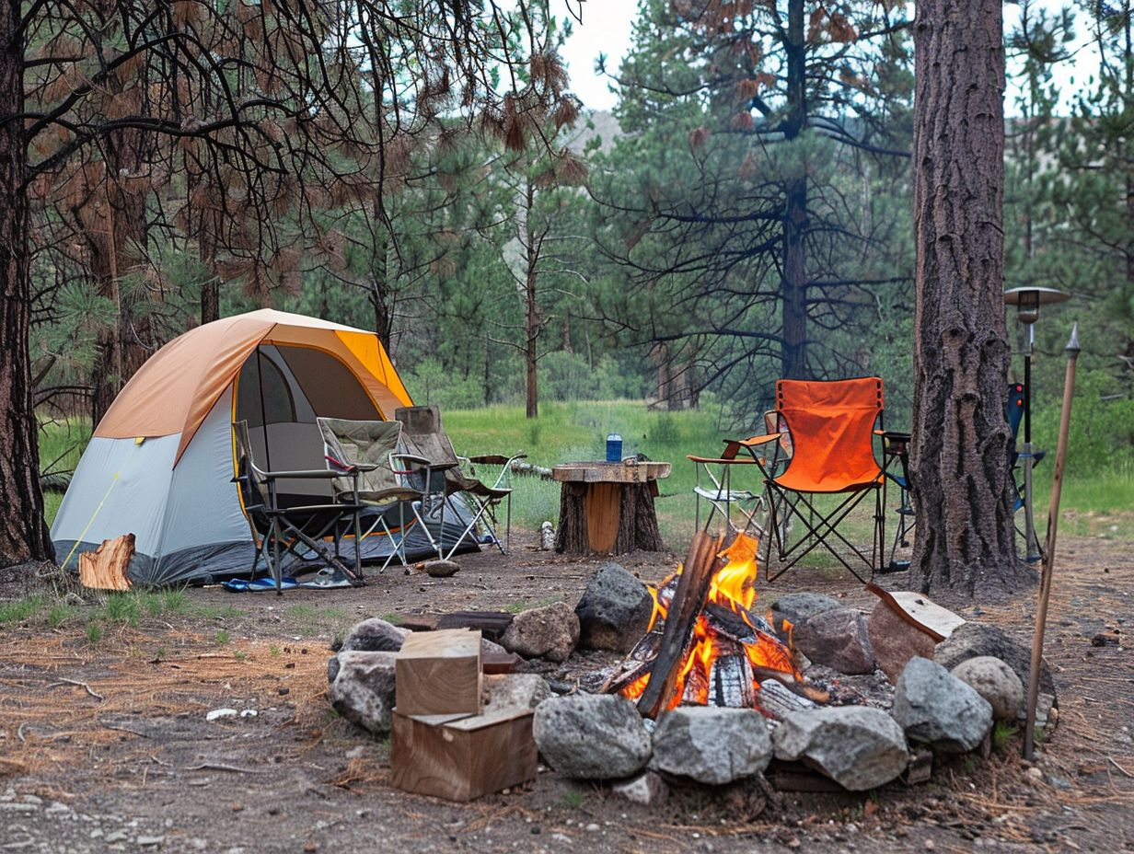

#### Consider the compound preposition "into" describing the raccoons' disappearance into the darkness. What does this choice of preposition convey about the raccoons' actions and the mood of the scene?

**Ans.** The preposition "into" suggests the raccoons' quick and seamless retreat, highlighting their instinctive and mysterious behavior. It adds a sense of intrigue and uncertainty to the scene, enhancing the mood of the night and the wilderness.

#### In the sentence "They walked through the dense forest," what does the compound preposition "through" imply about the nature of the forest and the difficulty of the journey? Ans.The preposition "through" implies that the characters are moving from one side of the forest to the other, suggesting that the forest is a significant obstacle they must traverse. It emphasizes the density of the forest, indicating it is thick, challenging to navigate, and perhaps daunting. This word choice highlights the effort required to make the journey, creating a sense of persistence or determination in the characters. The word "through" conveys progression and struggle, which might symbolize overcoming obstacles or hardships. It suggests that the forest is not just a backdrop but a central element of the journey, adding depth to the story's setting and mood.

1. **The phrase "above the treetops" is used to describe the sunrise. How does this compound preposition create a vivid mental image of the sunrise and its significance to the story's conclusion?  
   Ans.** The phrase "above the treetops" evokes an image of the sunrise as it emerges over the forest canopy, casting light on the scene below. It emphasizes the vastness and beauty of nature, suggesting hope, renewal, or a peaceful ending to the story. The sunrise serves as a metaphor for a fresh start or the end of an eventful journey. This compound preposition helps readers visualize the sunrise as a breathtaking moment, symbolizing closure and harmony after the challenges the characters may have faced. It ties the story's conclusion to a sense of calm and resolution.

#### If you were to rewrite a part of the story using a different compound preposition, how would it change the meaning or atmosphere of that particular scene? Choose a sentence from the story and provide an alternative compound preposition. Explain the impact of this change. Ans.

**Original Sentence:** "The sun rose above the treetops, casting a golden glow on the campsite."

**Modified Sentence:** "The sun rose between the treetops, casting a golden glow on the campsite."

Changing "above the treetops" to "between the treetops" alters the imagery and atmosphere of the scene. The original phrase, "above the treetops," conveys an expansive and uplifting view, emphasizing the grandeur of nature and the dawn of a new day. In contrast, "between the treetops" creates a more confined and intimate image, suggesting the sun's rays are peeking through gaps in the trees. This change shifts the tone from one of vast openness to one of closeness and detail, possibly evoking a more secluded or tranquil mood at the campsite.

### Analyze the role of prepositional phrases in setting the scene. How do phrases like “through the dense forest” and “beside a sparkling river” contribute to the reader’s mental imagery of the camping location?

### Ans.

#### "Through the Dense Forest" evokes a vivid mental image of a secluded, natural setting, emphasizing the lush greenery and the effort required to navigate the wilderness. It sets the tone of adventure and exploration.

#### "Beside a sparkling river" suggests an attractive and serene spot, enhancing the appeal of the campsite as calm and refreshing. The river's sparkle creates a visual impression of beauty and tranquility, balancing the rugged forest scene.

### 7. Identify instances where prepositional phrases are used to indicate location or direction. How do these phrases help the reader navigate the story’s physical setting and the movements of the characters?

**Ans.** Instances include:

* + "Around the campfire" (location)
  + "Toward the noise" (direction)
  + "Into the darkness" (movement)

These phrases guide the reader through the spatial and directional elements of the story. For example:

* + "Around the campfire" establishes where the friends gathered, creating a sense of community and warmth.
  + "Toward the noise" shows the characters' curiosity and movement toward an unknown sound, adding suspense.
  + "Into the darkness" indicates the raccoons’ exit, creating a mysterious conclusion to their appearance.

### 8. Examine the prepositional phrase “around the campfire” when the friends gathered. What does this phrase reveal about the social dynamics and atmosphere during their campfire gathering? Ans.

The phrase "around the campfire" suggests a central, shared space where the friends come together. It conveys a sense of unity, warmth, and intimacy as they sit close to each other. The campfire symbolizes comfort and light, contrasting with the surrounding darkness, which further emphasizes the cozy, communal atmosphere.

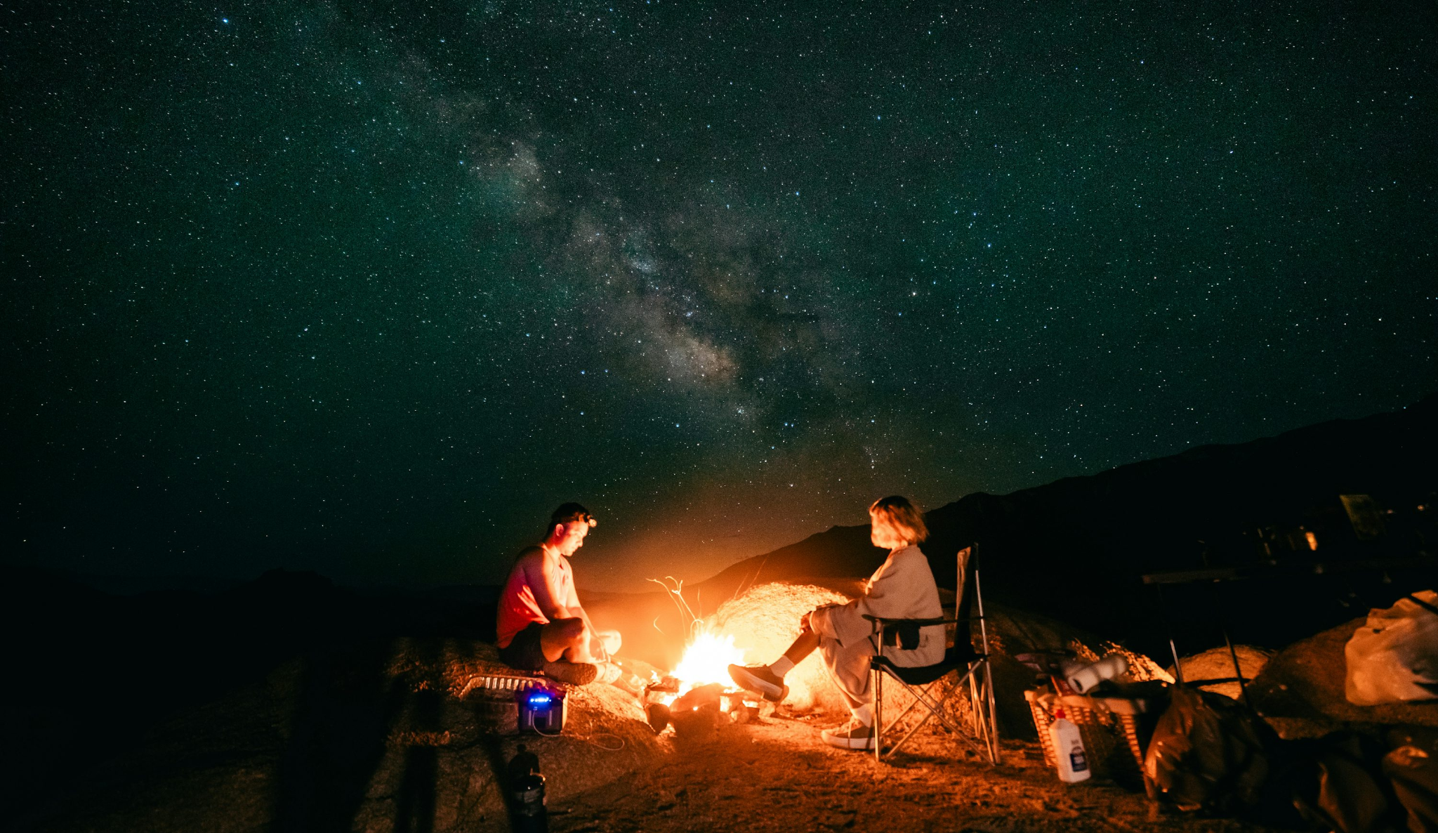

### 9. Consider the phrase “besides the raccoons” when Sarah places sandwiches. How does this prepositional phrase add a layer of meaning to the interaction between the friends and the raccoons? Ans."Beside the raccoons" implies a close physical proximity, indicating Sarah’s willingness to approach and share food with the animals. This phrase reflects kindness and respect for nature. It also shows an unspoken interaction between humans and animals, blending curiosity and mutual trust. The phrase portrays Sarah as empathetic and reinforces the theme of harmony with the natural world. It adds depth to the narrative by showing how small actions can create meaningful connections.

### 10. In the sentence “They packed their gear and hiked back through the forest to return home,” the phrase “to return home” signifies the purpose of the action. How do such purpose-indicating prepositional phrases help in storytelling and character motivation? Ans.The phrase "to return home" clarifies the intent behind the characters’ actions, providing a logical conclusion to their journey. It signifies a transition from adventure back to normal life, reflecting a sense of accomplishment and closure.

#### 11. If you were to rewrite a part of the story by changing or removing a prepositional phrase, how would it alter the reader’s understanding of the narrative? Choose a sentence from the story and provide an alternative or modified prepositional phrase. Explain the impact of this change.

**Ans.**

**Original Sentence:** "They walked **through the dense forest**, listening to the rustling leaves and chirping birds."

**Modified Sentence:** "They walked **past the dense forest**, listening to the rustling leaves and chirping birds."

Changing "through the dense forest" to "past the dense forest" alters the reader's understanding of the setting and the characters' experience. The original phrase suggests the characters are deeply immersed in nature, creating a vivid sensory experience as they navigate the forest. The modified phrase, "past the dense forest," implies the characters bypassed or skirted the forest, reducing the sense of adventure or engagement with their surroundings. This change makes the narrative less immersive and may affect the mood by diminishing the connection between the characters and nature.

**Conjunctions and Transitional Devices:**

**Conjunctions:**

Conjunctions are words that connect words, phrases, or clauses within a sentence. They help establish relationships between different parts of a sentence, making writing cohesive and logical.

**Examples:** *and, but, or, nor, for, so, yet, because, although, since, unless, while, if, though*

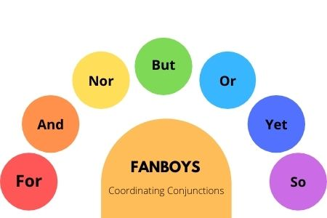

### Transitional Devices:

Transitional devices are words or phrases used to connect ideas between sentences or paragraphs. They guide the reader by showing relationships such as cause and effect, comparison, contrast, sequence, or emphasis.

#### Types of Transitional Devices:

1. **Addition:** To add information.
   * **Examples:** moreover, furthermore, in addition, also
   * **Example Sentence:** She is a talented singer; moreover, she can play the guitar.
2. **Contrast:** To show differences.
   * **Examples:** however, on the other hand, nevertheless, yet, instead
   * **Example Sentence:** He wanted to join the team; however, he lacked the required skills.
3. **Cause and Effect:** To show relationships of cause and effect.
   * **Examples:** therefore, consequently, thus, as a result, because of this
   * **Example Sentence:** It started raining heavily; therefore, we postponed the trip.
4. **Sequence/Order:** To show the order of ideas or events.
   * **Examples:** first, next, then, finally, afterward
   * **Example Sentence:** First, we went to the museum, and then we had lunch.
5. **Comparison:** To show similarities.
   * **Examples:** similarly, likewise, in the same way
   * **Example Sentence:** The two cities are bustling with life. Similarly, they both attract tourists.
6. **Emphasis:** To stress a point.
   * **Examples:** indeed, in fact, importantly, above all
   * **Example Sentence:** She is, in fact, the best candidate for the role.

**Difference Between Conjunctions and Transitional Devices:**

* **Conjunctions:** Work within a sentence to connect its parts.
  + Example: *I want to go, but I am too tired.*
* **Transitional Devices:** Link ideas across sentences or paragraphs to ensure smooth flow.
  + Example: *I am too tired to go. However, I will try my best.*

**Exercise:**

**Q: Fill in the Blanks with Appropriate Conjunctions:**

1. I wanted to go to the park, **but** it started raining heavily.
2. She studied hard for the exam, **so** she was determined to succeed.
3. He is allergic to peanuts, **so** he always checks food labels.
4. I was tired **because** I stayed up late to finish my assignment.
5. He wanted to buy the car, **but** he couldn’t afford it.

**Exercise: Combining Sentences Using Transitional Devices:**

1. The weather was cold; **however**, we decided to go for a hike.
2. She forgot her umbrella; **therefore**, she got soaked in the rain.
3. He missed the bus; **as a result**, he was late for the meeting.

## Correlative Conjunction:

Correlative conjunctions are pairs of words used together to link equal parts of a sentence. These pairs ensure that the sentence elements being connected are equivalent in terms of grammar (e.g., both nouns, adjectives, verbs, or phrases).

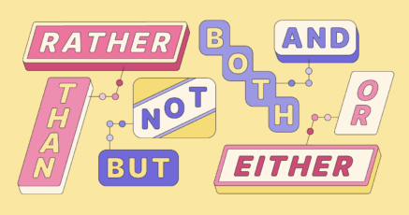

#### Common Correlative Conjunctions:

1. **Either…or**
   * Used to present two choices or possibilities.
   * Example: *Either go big or go home.*
     + **Analysis:** *Go big* and *go home* are both verbs.

#### Neither…nor

* + Indicates that none of the options are true or applicable.
  + Example: *It was neither big nor clever.*
    - **Analysis:** *Big* and *clever* are both adjectives.

#### Not only…but also

* + Emphasizes two linked elements, often to add surprise or importance.
  + Example: *They stole not only the TV but also the satellite dish.*
    - **Analysis:** *TV* and *satellite dish* are both nouns.

1. **Both…and**
   * Highlights two elements being equally valid or important.
   * Example: *Both my brother and I enjoy hiking.*
     + **Analysis:** *My brother* and *I* are both subjects.

#### The…not…but

* + Used to show contrast or correction.
  + Example: *The light was not green but red.*
    - **Analysis:** *Green* and *red* are adjectives describing the light.

**Other Examples:**

* “Either John or Sarah will bring dessert.”
* “She will either study or sleep after dinner.”
* “He is not only smart but also kind.”
* “You can either come with us now or wait for an hour.”

#### Q: Choose the correct correlative conjunction to complete the sentences:

1. **Both** John **and** Adam showed up at the party.
2. **Either** the rain stopped **or** the sun came out.
3. Sarah can speak **both** English **and** Spanish.
4. I will **either** play video games **or** watch TV tonight.
5. **Neither** Sam **nor** Tom wants to be the team captain.
6. **Whether** you can join us for dinner **or** let us know in advance.
7. **Whether** we go hiking **or** swimming, I'll be happy.
8. Mary enjoys **both** reading novels **and** watching movies.
9. Tim will **either** eat pizza **or** have a burger for dinner.
10. **Either** my friend **or** my brother knows the answer to that question.
11. She is **both** beautiful **and** intelligent.
12. **Either** the concert **or** the movie was canceled due to bad weather.
13. The team won **not only** because the players played with determination **but also** because of teamwork.
14. I want to **either** go to the beach **or** stay at home and read a book.
15. **Both** eating fruits **and** drinking lots of water are essential for health.
16. She can’t **either** play the piano **or** the guitar.
17. He is **not only** just an actor **but also** a talented singer as well.
18. I’m **both** running late **and** stuck in traffic.
19. The movie was **both** interesting **and** confusing.
20. **Either** my sister **or** my brother likes pizza.
21. We can **either** take the subway **or** a taxi to reach the station on time.
22. **Either** my parents **or** my teacher can attend the meeting.
23. **Both** Mary **and** John were able to solve the math problem.
24. I will **either** buy a new phone **or** get my old one repaired.
25. The dog is **neither** asleep **nor** awake.
26. **Whether** you like **or** you dislike, it’s important to respect others' opinions.
27. We can go for a walk **or** watch a movie at home.
28. The weather is **neither** too hot **nor** too cold today.
29. **Both** exercise regularly **and** eat a balanced diet if you want to stay healthy.
30. She couldn’t **either** swim **or** dance at the party.



